

SOFTWARE PROTOTYPE REPORT

ON

Campus Recruitment System

By
1.Mehul Patil (Scsb-305).
2.Niranjan Patil (Scsb-307).
3.Sanketkumar Sathe (Scsb-307).

DEPARTMENT OF COMPUTER ENGINEERING
MIT ACADEMY OF ENGINEERING
ALANDI (D), PUNE
2016 - 2017
.
MIT ACADEMY OF ENGINEERING
ALANDI (D), PUNE

DEPARTMENT OF COMPUTER ENGINEERING

CERTIFICATE

This is to certify that the software prototype project entitled “Campus Recruitment System” has been carried out by Mr. Mehul Patil , Mr. Niranjan Patil , Mr. Sanketkumar Sathe., under the guidance in partial fulfillment of Second Year Computer Engineering of Savitribai Phule Pune University, Pune during the academic year 2017-2018.

Mrs. Neha Hazare. Dr. S.A. Jain

Course Instructor Head of the Department

INDEX

Topic |  |  | Page No.
 | Abstract |  | 05
1. | Introduction |  | 05
 | 1.1 | Problem Statement | 05
 | 1.2 | Background and Motivation | 05
2. | Requirement Analysis |  | 06
 | 2.1 | User Requirements | 06
 | 2.2 | Functional Requirement | 07
 | 2.3 | Limitations | 12
 | 2.4 | Constraints | 12
 | 2.5 | Analysis | 12
3. | UML Design |  | 13
 | 3.1 | Use Case Design | 13
 | 3.2 | Sequence Design | 14
 | 3.3 | Activity Design | 16
4. | Working Prototype UI Design |  | 17
 | 4.1 | Sign in as student or HR | 17
 | 4.2 | Sign up for student | 17
 | 4.3 | Sign in for student | 18
 | 4.4 | To update or change profile | 18
 | 4.5 | Student can view company profile | 19
 | 4.6 | Student can see result of interview | 19
 | 4.7 | Student Profile | 20
 | 4.8 | Student List | 20
 | 4.9 | Visited Company | 21
 | 4.10 | Feedback | 21
 | 4.11 | After log out | 22
 | 4.12 | Sign up for HR | 23
 | 4.13 | HR tabs | 23
 | 4.14 | HR can see profiles of student | 24
 | 4.15 | HR put result of student | 24
 | 4.16 | HR can see responses of student | 25
5. | Conclusion |  | 26
6. | References |  | 26

Abstract

Every year college arranges campus recruitment drives for its students. Head of recruitment cell contacts HRs from different companies to conduct campus recruitment in the college. Once agreed, HR sends eligibility criteria to contact person. Now, this contact person needs to gather information of eligible students from all the departments. Once eligible students are identified, contact person needs to send announcements, phone calls to the concerned students to attend campus recruitment drive.

This process involves lot of manual work and once person has to do multiple tasks which if not done efficiently can cause havoc in campus recruitment drives. And also to save the time of all students , HR’s and the company persons .By providing them the single platform to conduct and proceed all the activities of placement very efficiently.

Introduction
  - Problem statement

Recruitment process involves a systematic procedure from sourcing the candidates to arranging and conducting the interviews and requires many resources and time

1.2 Background and Motivation

In the campus recruitment process student faces many problems like-student needs to fill many forms for different companies, visit to college frequently for checking notice boards and regarding the issues. The HR has to do multiple task which if not done efficiently can cause havoc in campus recruitment drives. Hence the campus recruitment process takes lots of manual work and time. So, we have to motivate that to create a app which is helpful, timesaver and reduces lots of manual work of student as well as HR.

2. Requirement Analysis

  - User Requirements
- Student has to fill only one form for all placements also Student has to maintain their own profiles details including their academic details and contact information.
- Student can check latest announcement and notifications which are sent to eligible candidates according to their contact information and preferences mentioned on their profile. Ex. A simple mass email/SMS can be sent to the list of eligible candidates.
- HR can filter eligible students for different companies and arranges recruitment drive for students satisfying "Eligibility Criteria".

2.2 Functional Requirement
2.2.1 Sign up:

PURPOSE | To create student id and account in system
USER | Last year students of college, HR
INPUT DATA | Enter name, enter date of birth, enter pin(for HR only), enter email id ,set password, confirm password.
OUTPUT DATA | User can log in system with this id and password
INVARIANTS | PRN Number, college mail ID
PRE-CONDITIONS | User should be college member
POST-CONDITIONS | Successful registration
BASIC FLOW | Users have to give his name, email id, and have to set password for his privacy with confirmation of password.

2.2.2 Sign in :
PURPOSE |  | To log in user into his private account
USER |  | Users who have registered in system
INPUT DATA |  | User name (email id) , password
OUTPUT DATA |  | Login successful
INVARIANTS |  | User name, password
PRE-CONDITIONS |  | User should have successful registration
POST-CONDITIONS |  | Login successful
BASIC FLOW | Entering proper username and password user can enter into the account

2.2.3. Forgot Password :
PURPOSE |  | To Create New Password
USER |  | Any user who don’t remember the original password
INPUT DATA |  | On received mail of forgot password option and  Create new password and confirm it.
OUTPUT DATA |  | New Password is created
INVARIANTS |  | Email ID
PRE-CONDITIONS |  | User should have an account.
POST-CONDITIONS |  | User should remember new password.
BASIC FLOW | User will select option “forgot password”, check the received email from app, create new password ,User login

2.2.4 Announcement:
PURPOSE |  | User (student) should get notifications of companies coming for campus recruitment
USER |  | Students
INPUT DATA |  | Nothing
OUTPUT DATA |  | Notifications of companies with their job profile ,salary, company bond, date of coming , procedure of section, criterion
INVARIANTS |  | Nothing
PRE-CONDITIONS |  | User(student) must be logged in and have to fill his resume in profile tab
POST-CONDITIONS |  | If student wish to apply that company then click on “Yes” option
BASIC FLOW | After log in user will go to announcement tab then user will go to that box or click on it and user can get all information of that company
2.2.5 Activity :
PURPOSE |  | User can see all the list of selected candidate of company with their profile. User can also see his status in company rounds
USER |  | Registered User(student)
INPUT DATA |  | Nothing
OUTPUT DATA |  | List of recently visited companies with selected candidates and tab of user status
INVARIANTS |  | Nothing
PRE-CONDITIONS |  | Student must be logged in and has to fill resume in profile tab
POST-CONDITIONS |  | Nothing
BASIC FLOW | Student will go to activity tab then he can see the recently visited companies and list of selected candidates .User can check his status of company rounds

2.2.6 HR
PURPOSE |  | Tab for HR to give notifications, and to see students’ profile/resume and to put list of selected candidates and to see candidates entering in placement procedure.
USER |  | HR only
INPUT DATA |  | Box to put notifications of companies and to put list of selected candidates
OUTPUT DATA |  | List of candidates entering in placement and their profiles/resumes
INVARIANTS |  | Nothing
PRE-CONDITIONS |  | User should be HR
POST-CONDITIONS |  | User should be HR
BASIC FLOW | HR will go to tab then can put notifications of companies and list of companies visited in campus and he can see list of students admitting in system and their profiles

2.2.7. View/ Update Profile:
PURPOSE |  | for students to update and view their resumes and to edit their primary information
USER |  | Students only
INPUT DATA |  | All primary information and boxes to fill their resumes with edit option.
OUTPUT DATA |  | Their resumes
INVARIANTS |  | Nothing
PRE-CONDITIONS |  | User should logged in system
POST-CONDITIONS |  | Nothing
BASIC FLOW | Student will go to profile tab and can update  Or fill resume

2.2.8 Sign out:
PURPOSE |  | To log out in user into his private account
USER |  | Users who have registered in system
INPUT DATA |  | User sign in system
OUTPUT DATA |  | Log out system
INVARIANTS |  | Nothing
PRE-CONDITIONS |  | User should have successful sign in
POST-CONDITIONS |  | Sign in page is view
BASIC FLOW | Click on sign out option

2.2.9 Feedback:
PURPOSE |  | Write feedback about campus recruitment process to HR
USER |  | Student
INPUT DATA |  | Suggestion
OUTPUT DATA |  | Display message “Your feedback is to be send to HR.”
INVARIANTS |  | Data
PRE-CONDITIONS |  | User should log in
POST-CONDITIONS |  | Feedback goes to HR
BASIC FLOW | Click on Feedback option, Enter your feedback, and click on submit.

2.3 Limitations
- Verification of document is not done in the app
- Can’t prepare for aptitude tests
- Other college student cannot access the app.

2.4Constraints
- Student cannot view other student profile.
- HR can’t edit student profile.
- Student’s password can’t be shared.
- Only HR’s can edit the Announcement ,Activity
- Student cannot see the others feedbacks

2.5 Analysis:
We learn to use Software Engineering Concepts in Prototyping ,to apply the Software Development cycle, to use AEIOU frame work for Project Statement, to operate in a group, to justify the Use of prototyping Tools, to analyzed the identified requirements of the project, to differentiate UML diagrams, to provide solution to real time problem, to demonstrate the group work ,to conclude the group activity, to summarize the project work done, to illustrate the functional behavior of the project

3. UML Design
3.1 Use Case Design
Figure 1: use case diagram
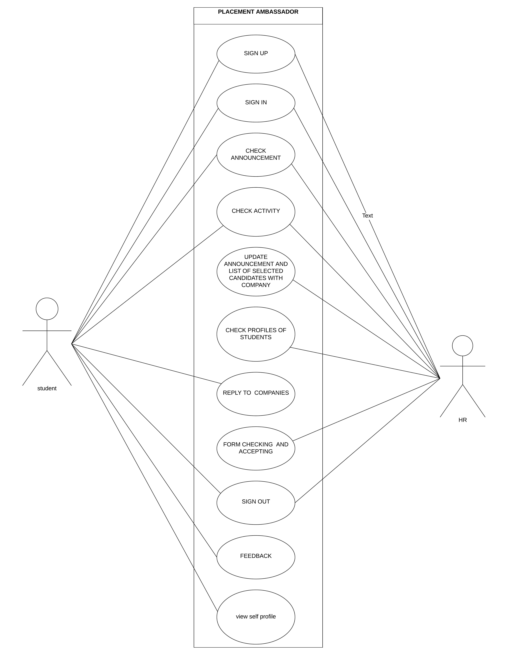
3.2 Sequence Design
Figure 2: Student view
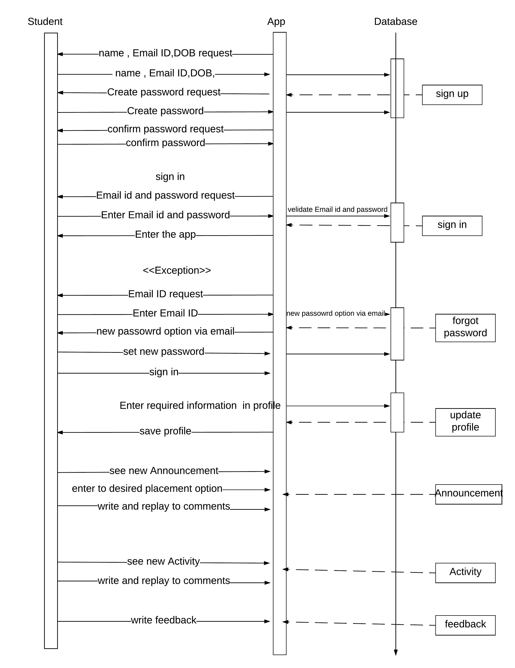
Figure 3:HR view
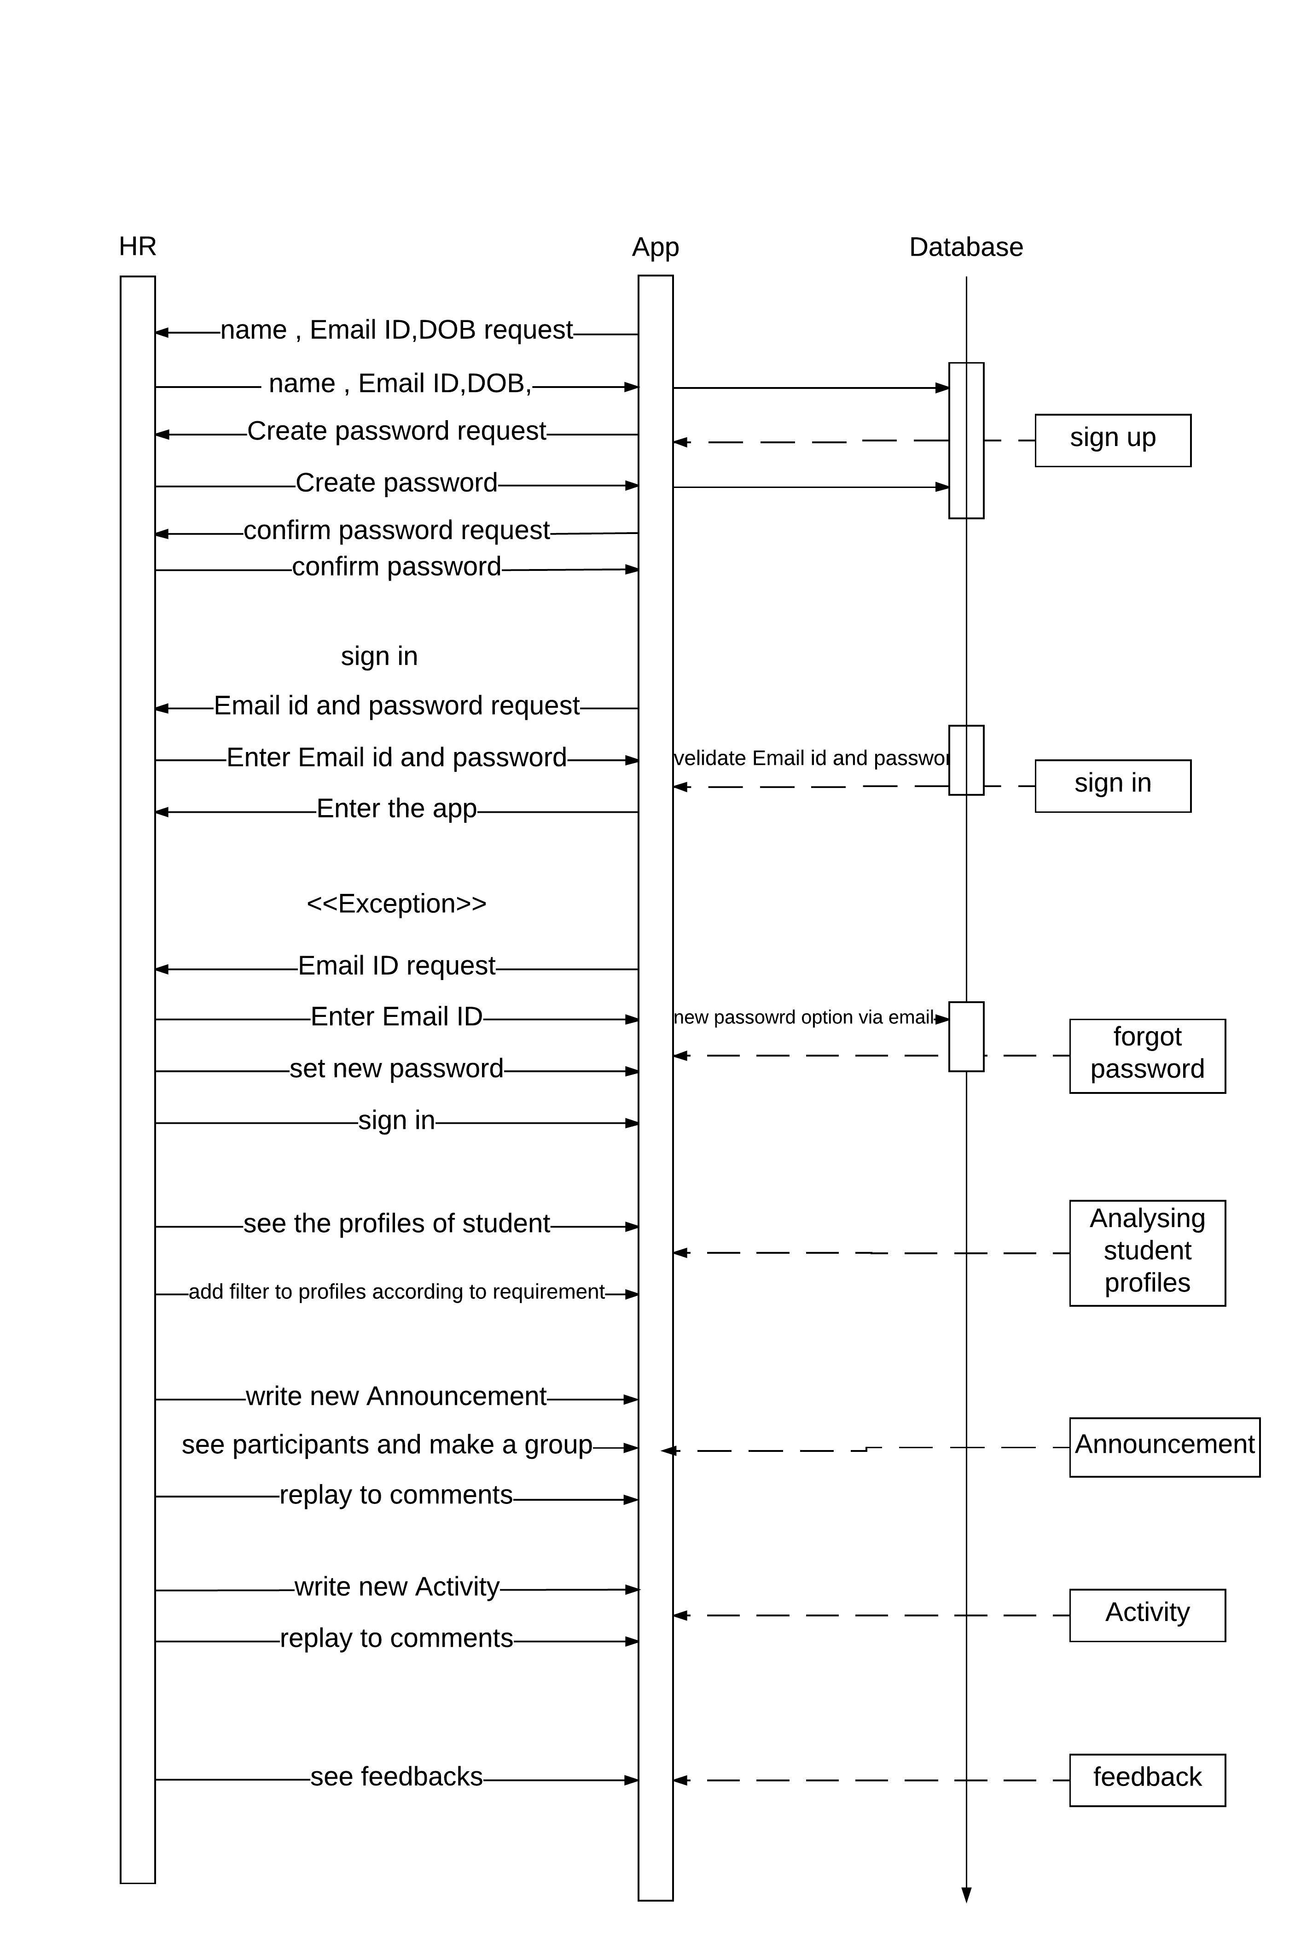
3.3 Activity Design
Figure 4Activity diagram
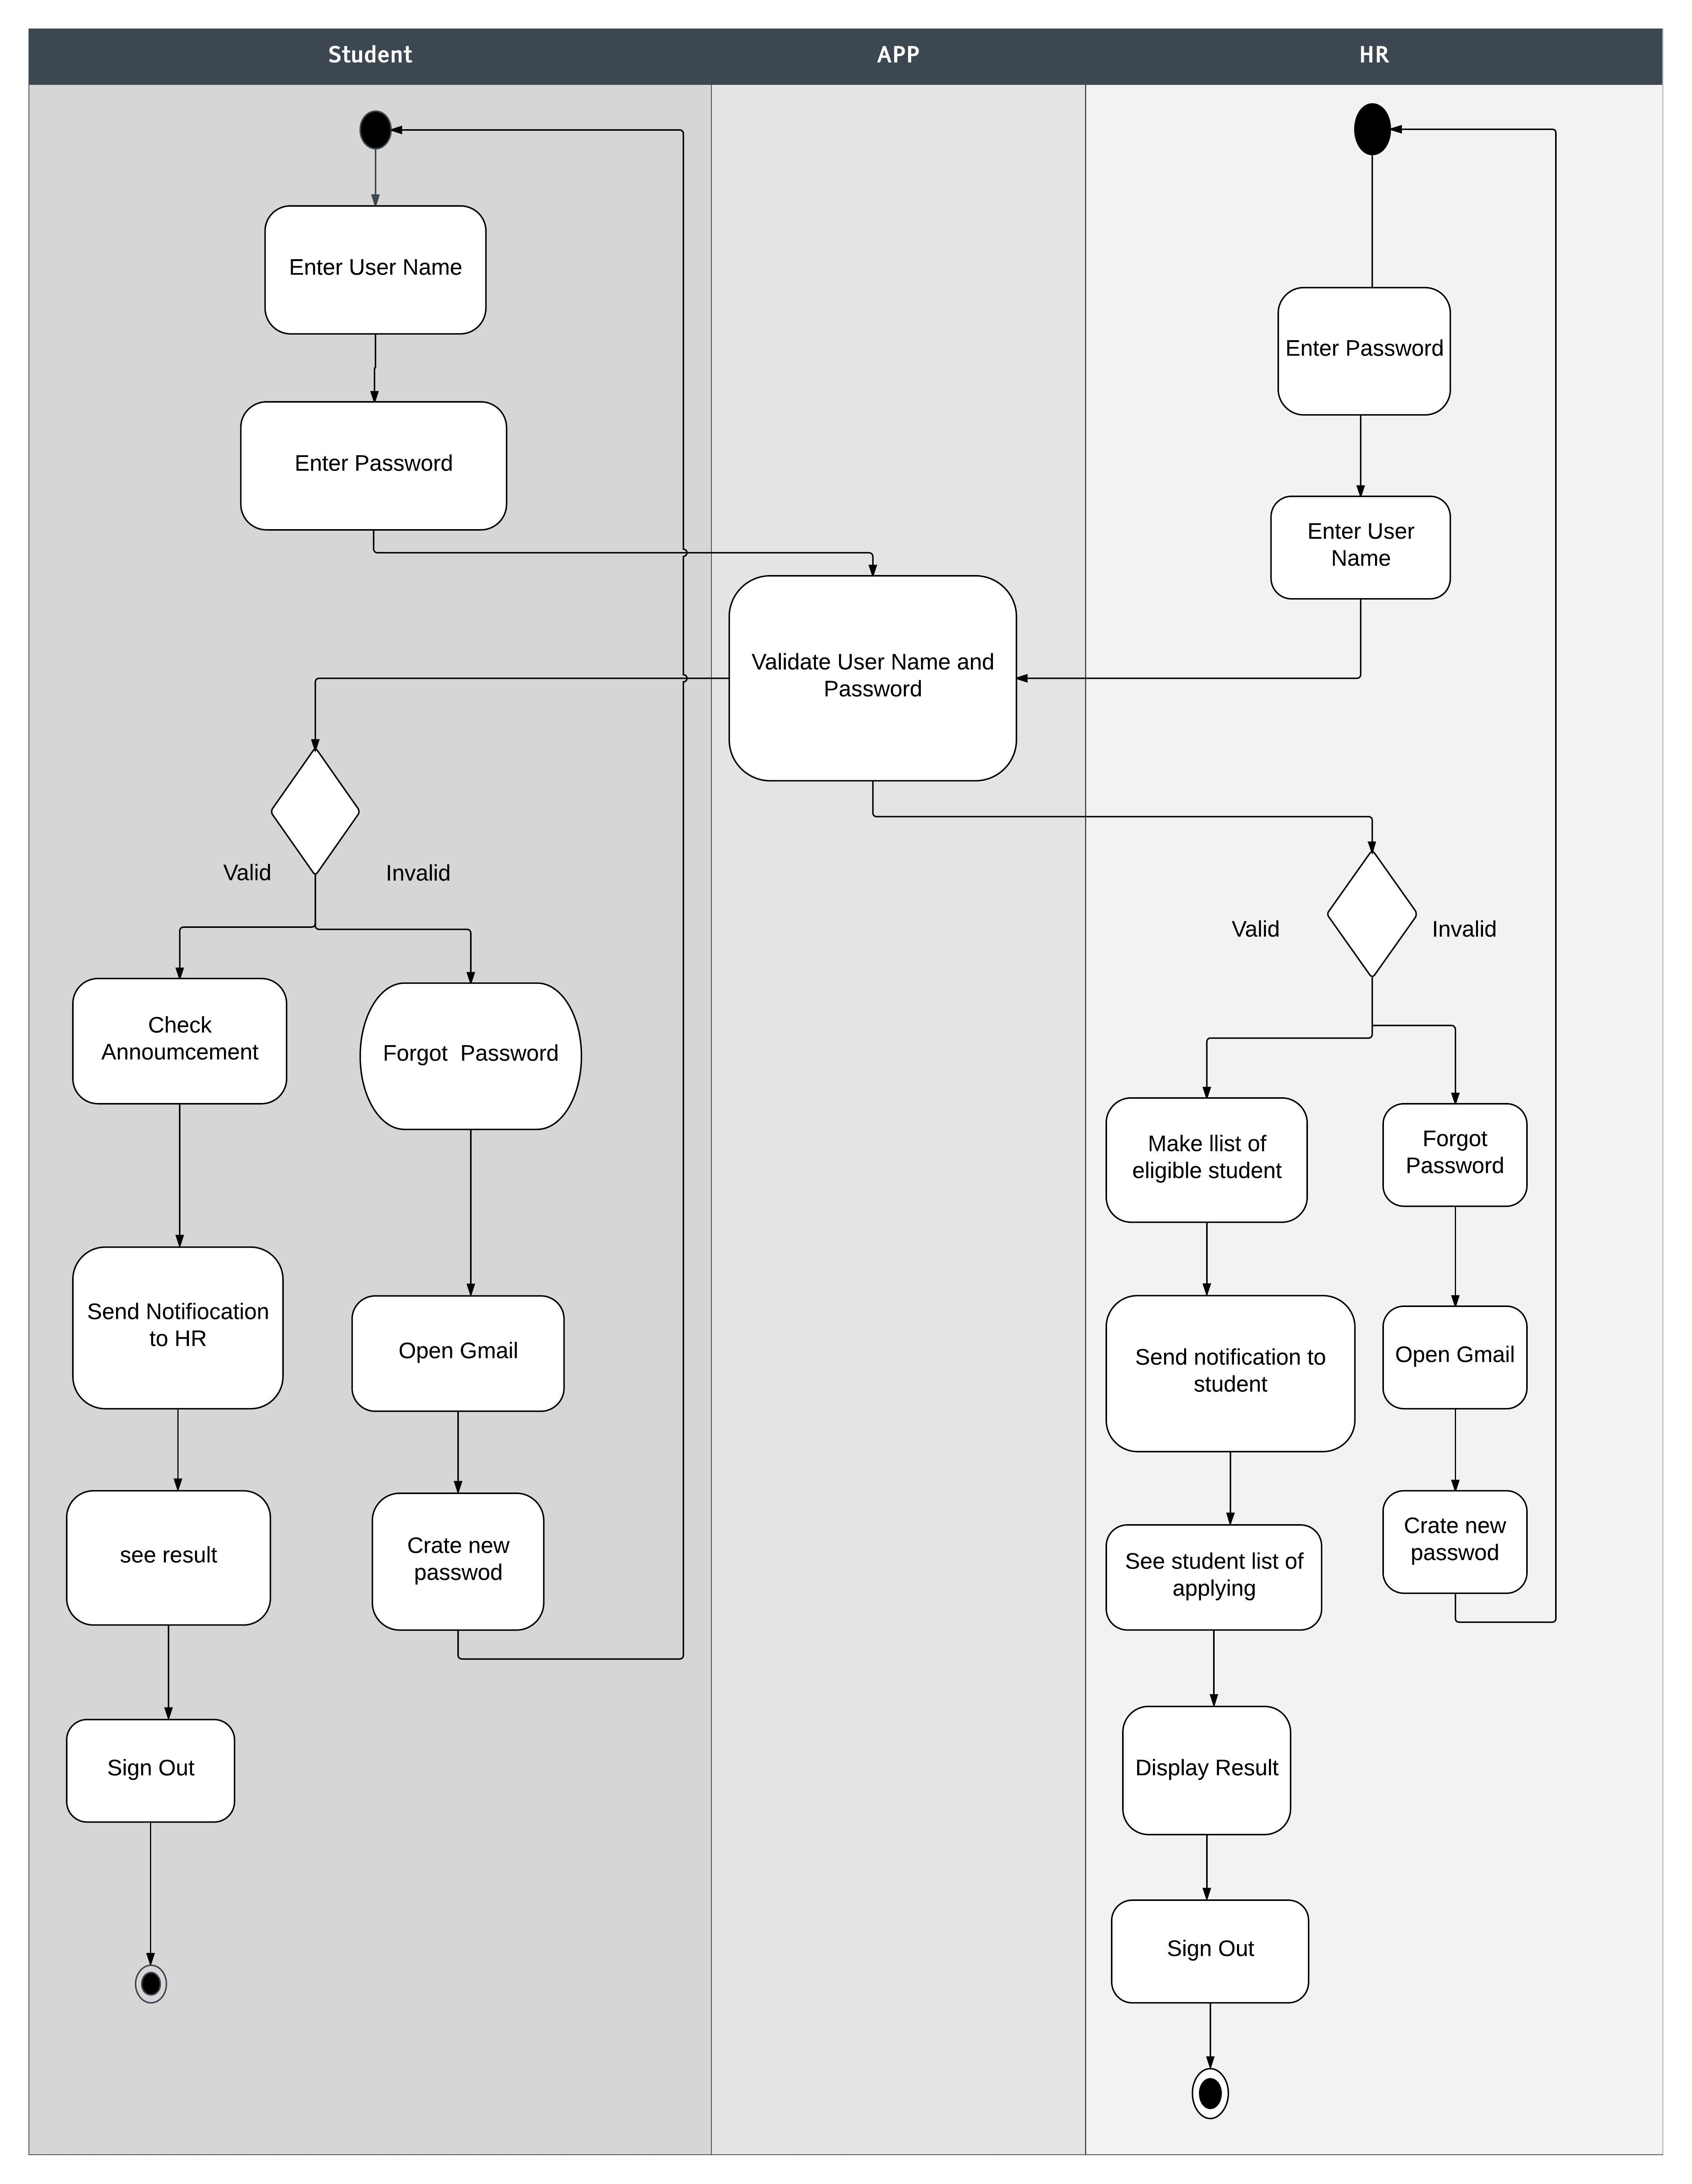
- Working Prototype UI Design
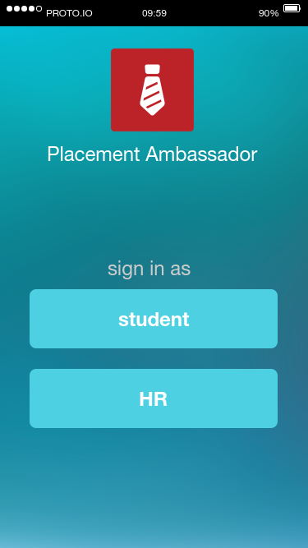
Figure 4.1 Sign in as student or HR
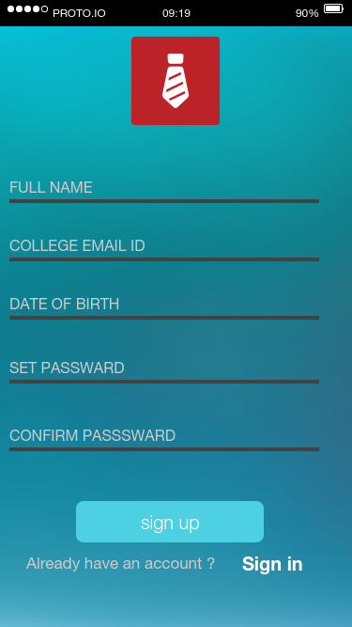

Figure 4.2 Sign up for student

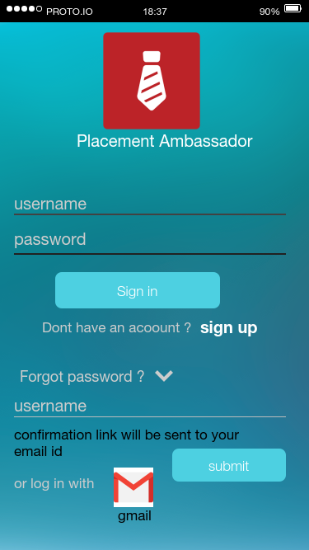

Figure 4.3 Sign in for student

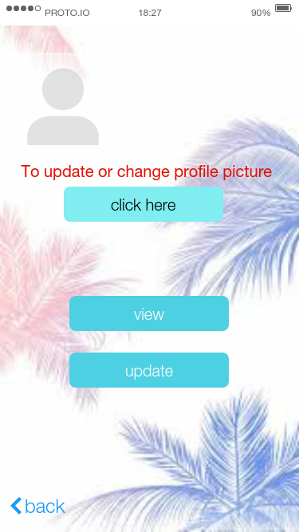

Figure 4.4 To update or change profile.

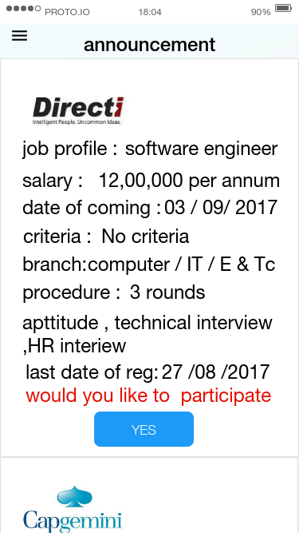

Figure 4.5 Student can view company profile.

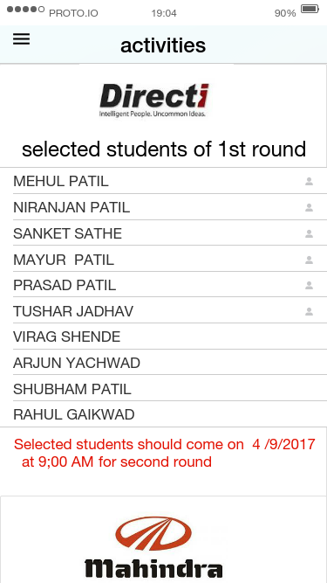

Figure 4.6 Student can see result of interview.

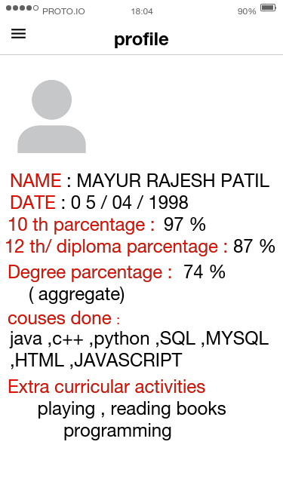

Figure 4.7 Student profile
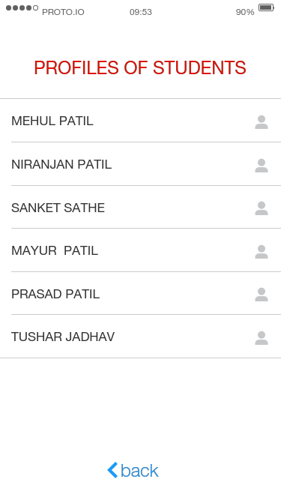
Figure 4.8 Student List
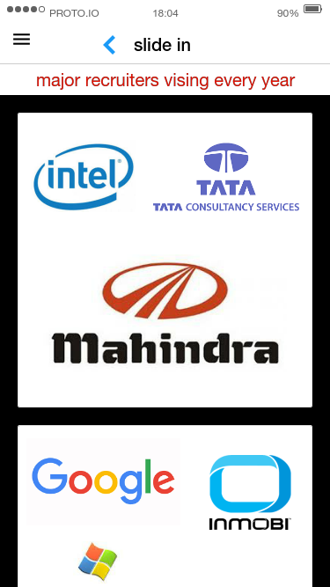
Figure 4.9 Visited Companies

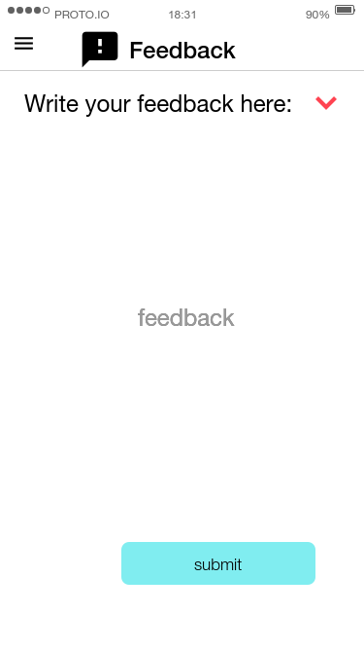
Figure 4.10 Feedback
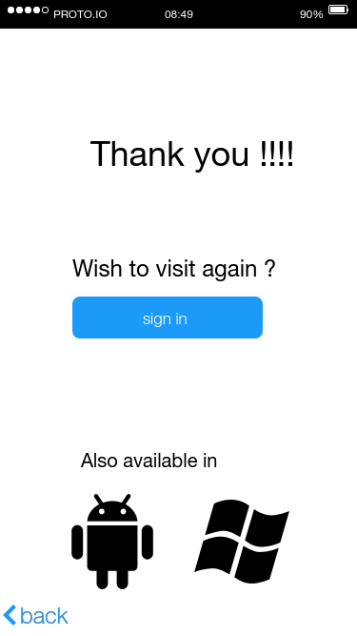

Figure 4.11 after log out

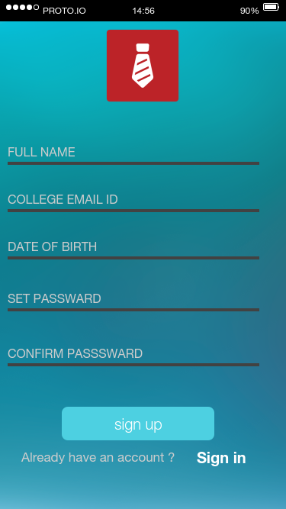

Figure 4.12 Sign up for HR
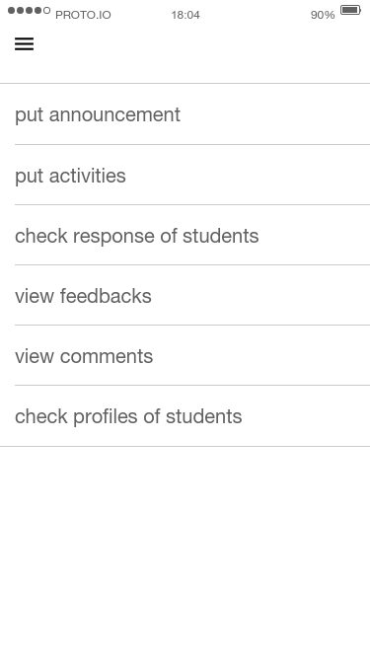
Figure 4.13 HR tabs
Figure 4.14 HR can see profiles of student

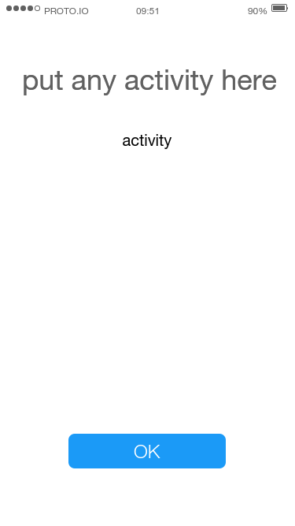
Figure 4.15 HR can put result of student

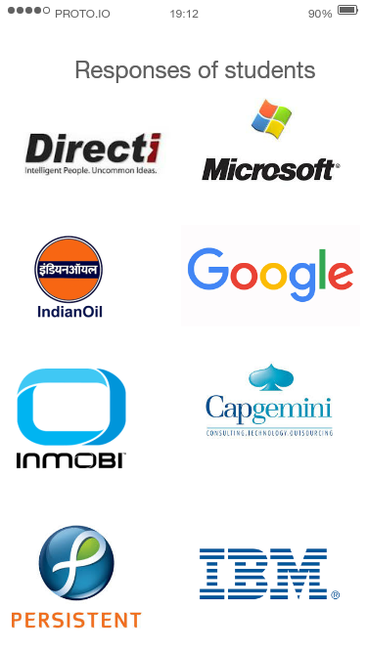

Figure 4.16 HR can see Responses of student

5. Conclusion
We have fulfilled all aspects of recruitment drive in this application.
6. References
- Engineering Practitioner’s Approach by Roger S. Pressman
- Software requirement specification by Dr. S. C. Gupta

